Excel Dashboard Project
1. Introduction
Data visualization is an essential technique for analyzing and interpreting large datasets. Microsoft Excel provides powerful tools such as Pivot Tables, charts, slicers, and formatting features that allow users to convert raw data into meaningful insights. In this project, an interactive dashboard is created using Excel to analyze customer data related to bike purchases. The dashboard consolidates multiple visualizations into a single worksheet, making it easier to interpret patterns and trends within the dataset.
The objective of this project is to demonstrate how raw data can be cleaned, analyzed, and transformed into an interactive dashboard that supports data-driven decision making.

2. Dataset Overview
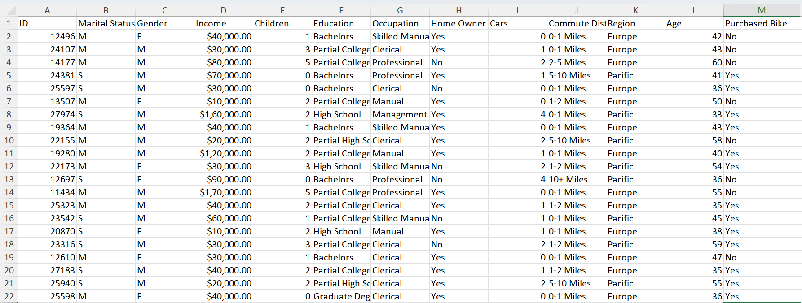
The dataset used in this project contains customer information related to bike purchases. The data includes attributes such as:
- Customer ID
- Marital Status
- Gender
- Age
- Income
- Education Level
- Region
- Commute Distance
- Whether the customer purchased a bike
Among these columns, the “Purchased Bike” field plays an important role because it indicates whether a customer bought a bicycle or not. This variable is used as a key factor in analyzing customer purchasing behavior.

3. Data Cleaning and Preparation
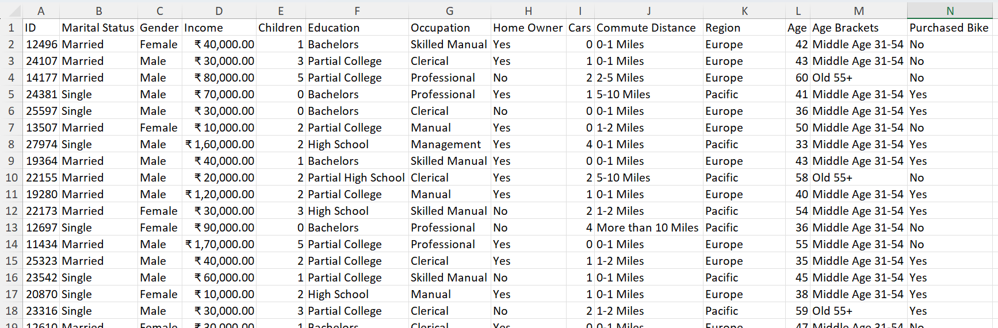
Before creating visualizations, the dataset was cleaned and formatted to improve accuracy and readability.
Duplicate Removal
Duplicate records were removed to ensure that each entry in the dataset represents a unique customer.
Data Standardization
Some columns contained abbreviated values. These were converted into full words for better readability.
Examples include:
- M → Male
- F → Female
- S → Single
- M → Married
Data Formatting
Numeric fields such as income were formatted in currency format to maintain consistency and improve presentation.
Creating Age Brackets
To simplify analysis, a new column called Age Brackets was created. Instead of displaying individual ages, customers were grouped into categories using nested IF statements.
Example age groups:
- Adolescent
- Middle Age
- Old
This grouping helps in identifying trends more clearly during visualization.

4. Data Analysis Using Pivot Tables
Pivot Tables were used to summarize and analyze the dataset efficiently. They allow large datasets to be transformed into structured summaries.
Several pivot tables were created to analyze different aspects of the dataset.
Average Income Analysis
A pivot table was created to analyze average income based on gender and bike purchase status.
The analysis revealed patterns such as:
- Male customers generally had higher average income.
- Customers with higher income were more likely to purchase bikes.
This pivot table helped identify the relationship between income level and purchasing behavior.

5. Visualization Using Charts
Charts were created based on the pivot tables to present the insights visually.
Examples of charts used in the project include:
Income vs Bike Purchase Chart
A chart was created to compare the average income of customers who purchased bikes and those who did not, categorized by gender.
Axis titles and chart titles were added to improve clarity and readability.
Commute Distance Analysis
Another pivot table analyzed bike purchases based on commuting distance. The data was organized in a proper order so that it could be visualized clearly.
Age Bracket Analysis
A chart was created to analyze how bike purchases vary across different age groups. Using age brackets made the visualization easier to understand compared to displaying individual ages.
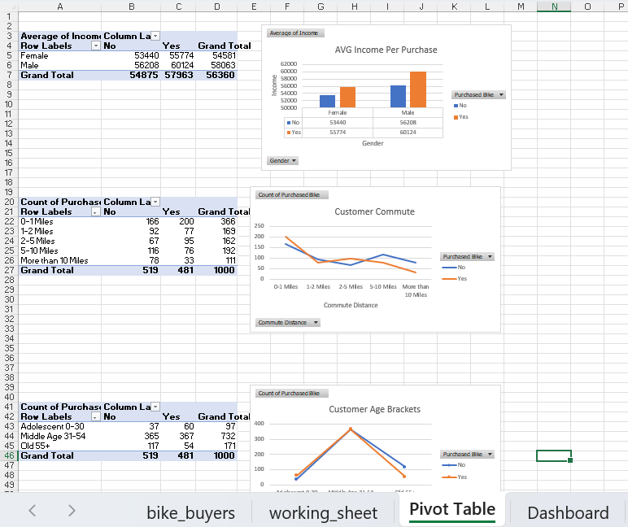
6. Dashboard Creation
After creating the charts, a dedicated worksheet was used to build the dashboard.
The dashboard design involved:
Removing Gridlines
Gridlines were hidden to make the dashboard appear cleaner and more professional.
Creating a Dashboard Header
Cells were merged and centered to create a title for the dashboard.
Applying a Color Theme
A consistent color scheme was applied across charts and visual elements to improve visual appeal.
Aligning Visualizations
Charts were carefully aligned to ensure a structured and organized layout.
These design steps improved the readability and professional appearance of the dashboard.
7. Adding Interactive Filters (Slicers)
To make the dashboard interactive, slicers were added.
Slicers allow users to filter the entire dashboard dynamically based on selected categories.
Examples of slicers used in the dashboard include:
- Marital Status
- Region
- Education Level
When a slicer is selected, all the charts in the dashboard update automatically, allowing users to explore the data from different perspectives.
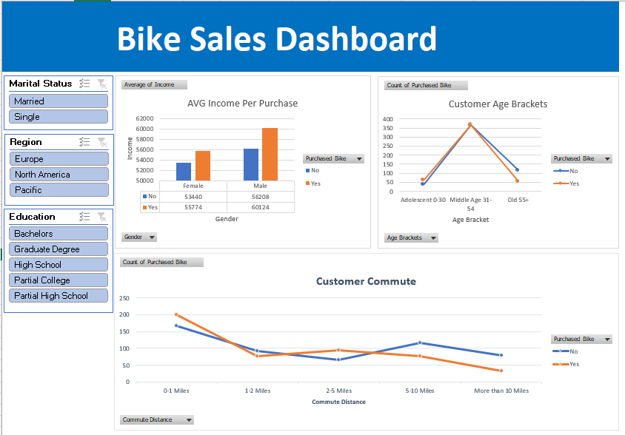
8. Key Insights from the Dashboard
The dashboard provides several insights about customer behavior:
- Customers with higher income are more likely to purchase bikes.
- Gender differences exist in income levels and purchasing behavior.
- Commuting distance can influence the likelihood of purchasing a bike.
- Age groups show different purchasing trends.
These insights demonstrate how dashboards can help organizations understand customer patterns and make better business decisions.

9. Conclusion
This project demonstrates how Microsoft Excel can be used to transform raw data into a professional and interactive dashboard. Through data cleaning, pivot table analysis, chart creation, and dashboard design, the dataset was converted into a visually appealing and informative interface.
The use of slicers and well-organized charts allows users to interact with the data and explore insights easily. This project highlights the importance of data visualization and dashboard design as valuable skills in data analysis and business intelligence.

